A picture containing clipart

Description generated with very high confidence

Azure 103 Module 4

Hands On - 7

Azure Certification Training

[**support@intellipaat.com**](mailto:support@intellipaat.com)

**+91-7022374614**

**US: 1-800-216-8930(Toll Free)**

**Azure 103 Module 2 , Hands On – 7**

**Connect To File Share to Linux PC**

**Step 1:** Open File Share.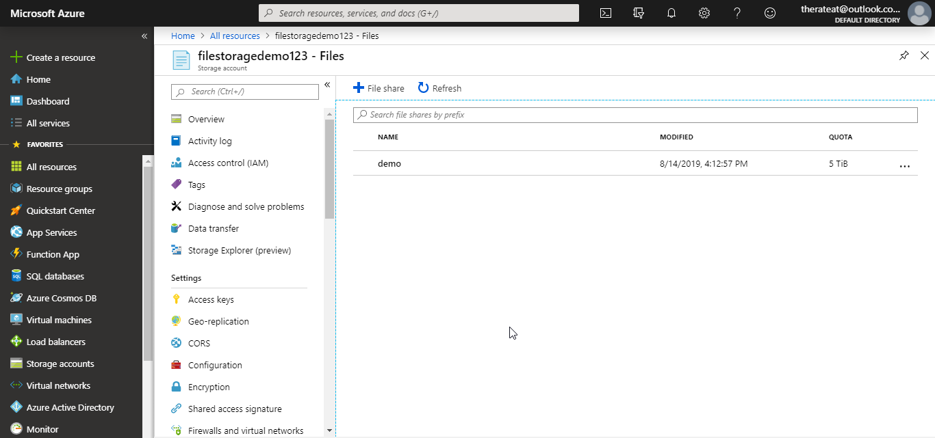

**Step 2:** Click on connect.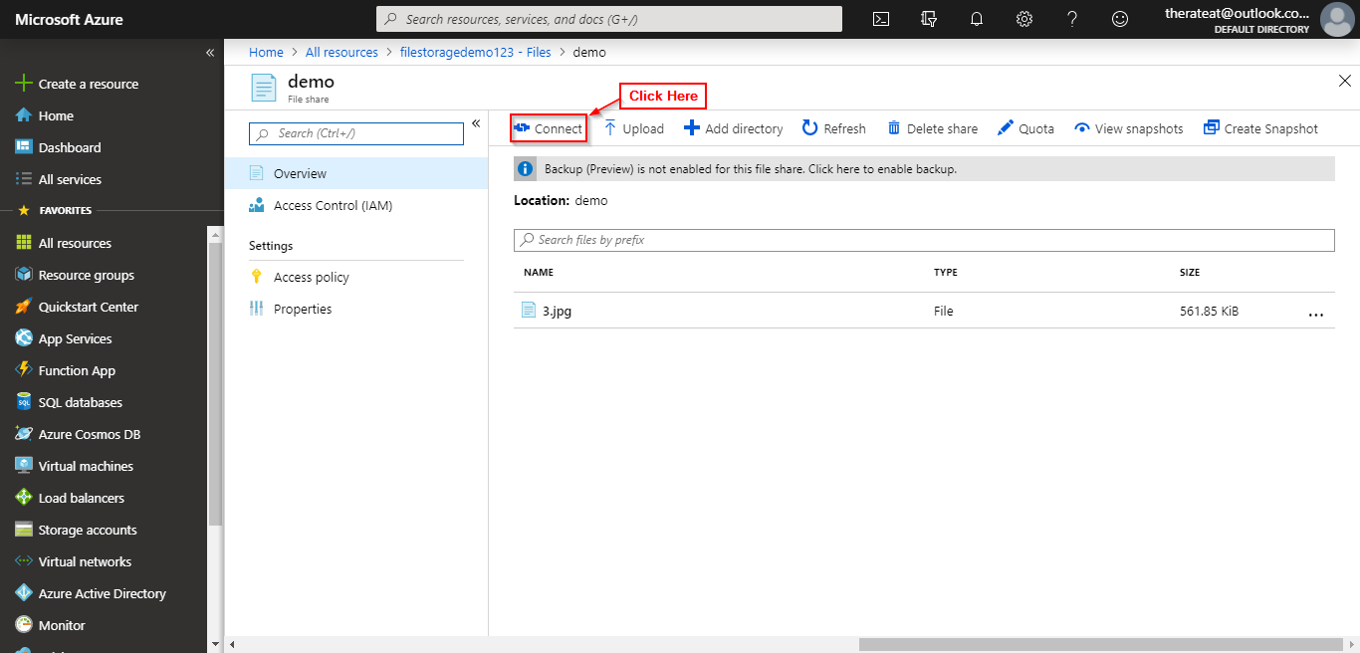

**Step 3:** Click on Linux Tab.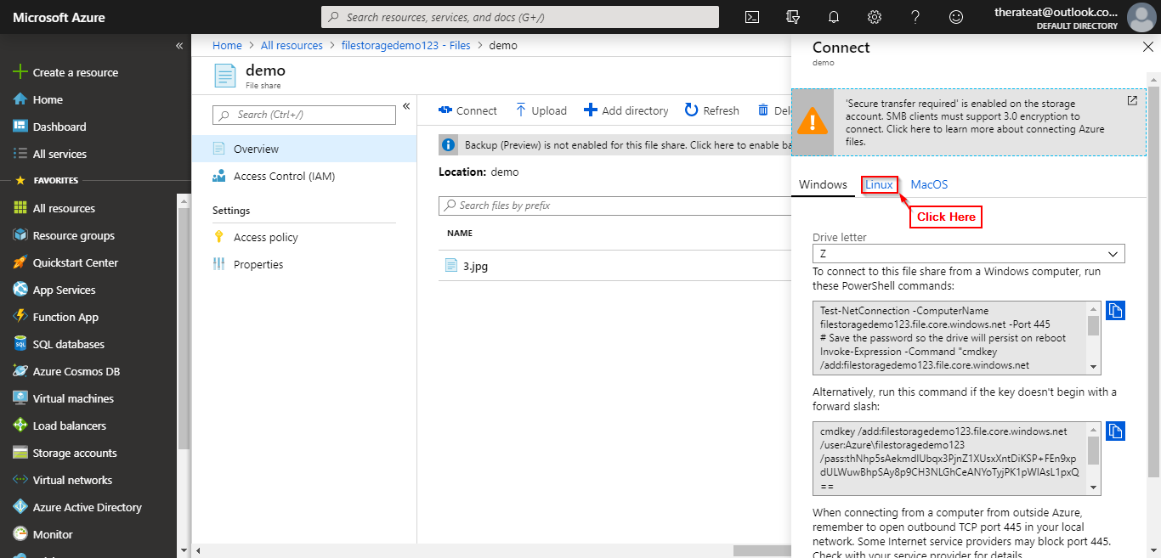

**Step 4:** Copy the command given to connect to File Share.

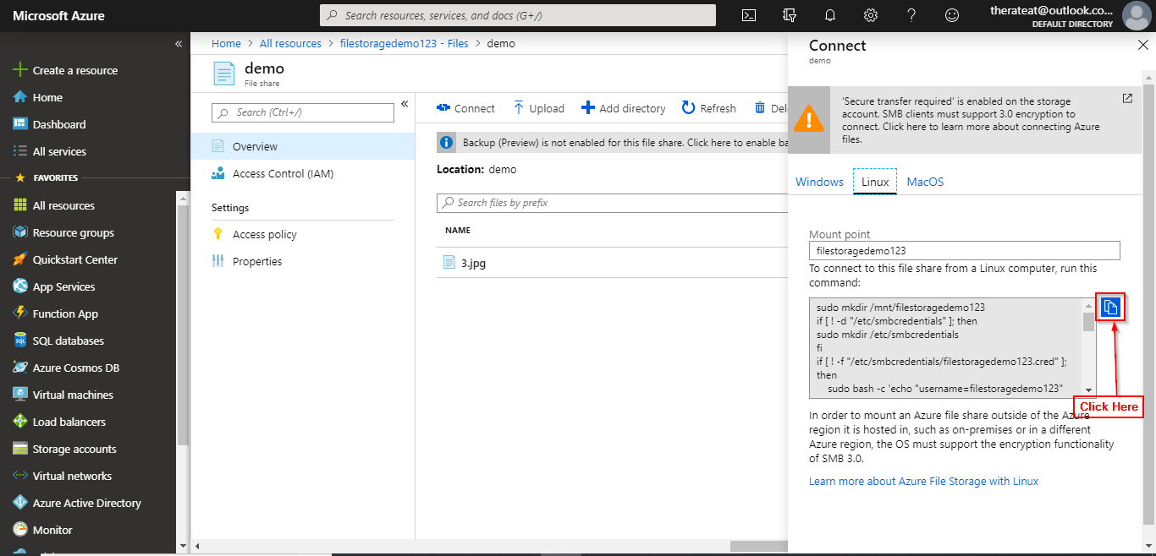

**Step 5:** Paste the copied command in the terminal.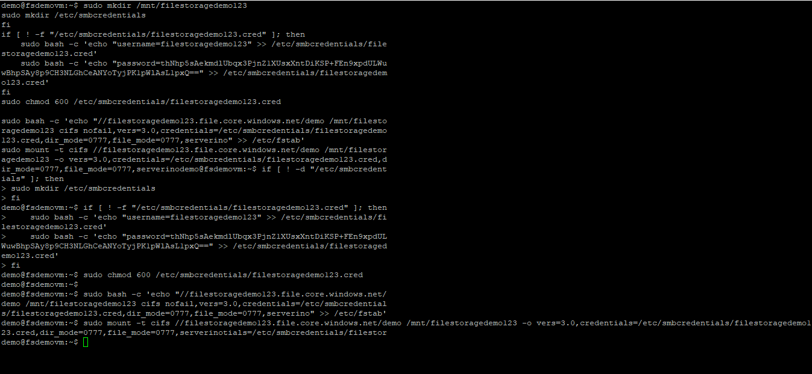

**Step 6:** File share is now mounted at /mnt/filestoragedemo123 for you to use.